**Department of Electrical and Computer Engineering**

**North South University**





**Directed Research – Update**

**Road Defect Detection Using Image Annotation**

**Md Sehabub Zaman Pranta 1611251042**

**Tanvir Ahmed 1410982042**

**Date:** 08.12.2020

**Course:** CSE498R

**Section:** 9

**Faculty Advisor:**

**Dr. Mohammad Ashrafuzzaman Khan**

Assistant Professor

Department of Electrical & Computer Engineering

Fall 2020

We have used several algorithms to solve road defect detection problems like ResNet, Inception network, Yolo V3, and Mask R-CNN. Among these algorithms, the Mask R-CNN produced the best results.

**Mask R-CNN experiment details**

We have experimented with Mask R-CNN on two sets of data. The first set contains roughly 700 data and the improved second set contains approximately 1300 data.

**Experiment results on 700 data**

We have trained for 50 thousand iterations then evaluated the validation set with AP matrix with a 70% inference threshold. Figures below showing the training results in graphs.

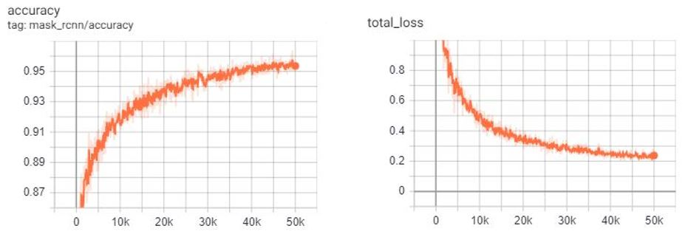

Figure . Resnet-50 backbone with 64 batch size

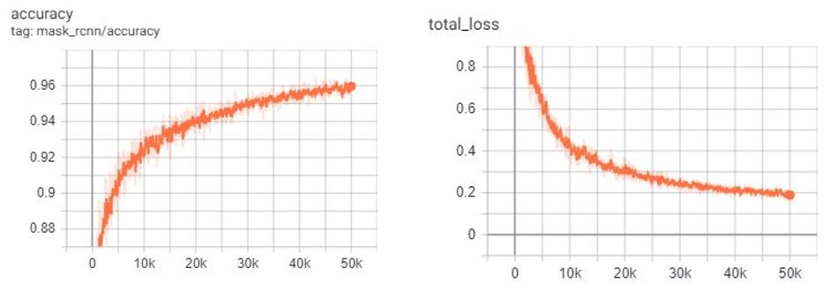

Figure . Resnet-101 backbone with 64 batch size

Now Evaluating validation set with AP matrix:

|  |  |  |  |  |  |  |  |  |
| --- | --- | --- | --- | --- | --- | --- | --- | --- |
| **Iteration** | **Backbone** | **Batch size** | **AP** | **AP50** | **AP75** | **APs** | **APm** | **APl** |
| 50k | ResNet-101 | 64 | 19.693 | 46.633 | 13.456 | 0.000 | 14.357 | 26.079 |
| 50k | ResNet-50 | 64 | 17.016 | 39.925 | 9.624 | 0.000 | 11.517 | 23.012 |

Table . Segmentation result with AP matrix with 700 data

**Experiment results on 1300 data**

We have trained for 60 thousand iterations then evaluated the validation set with AP matrix with a 70% inference threshold. Figures below showing the training results in graphs.

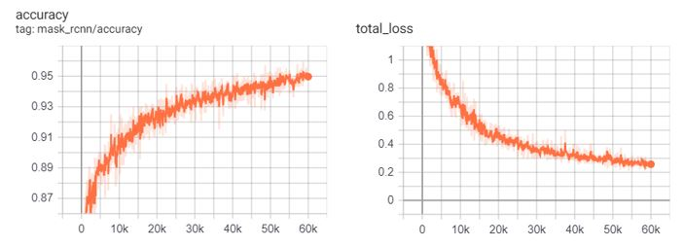

Figure . Resnet-101 backbone with 32 batch size

Now evaluating validation set with AP matrix:

|  |  |  |  |  |  |  |  |  |
| --- | --- | --- | --- | --- | --- | --- | --- | --- |
| **Iteration** | **Backbone** | **Batch size** | **AP** | **AP50** | **AP75** | **APs** | **APm** | **APl** |
| 60k | ResNet-101 | 32 | 24.962 | 48.937 | 21.985 | 9.624 | 26.289 | 28.696 |

Table . Segmentation result with AP matrix with 1300 data

**Comparing inference results**

Base Image

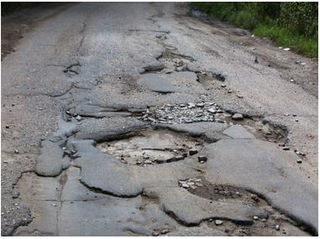

Segmented Image (After training with 700 samples)

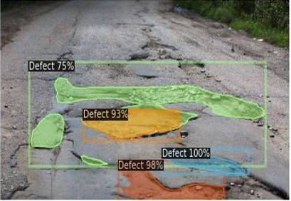

Segmented Image (After training with 1300 samples)

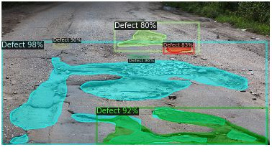

Now comparing the AP matrices:

|  |  |  |  |  |  |  |  |  |
| --- | --- | --- | --- | --- | --- | --- | --- | --- |
| **Iteration** | **Backbone** | **Batch size** | **AP** | **AP50** | **AP75** | **APs** | **APm** | **APl** |
| 50k | ResNet-101 | 64 | 19.693 | 46.633 | 13.456 | 0.000 | 14.357 | 26.079 |
| 50k | ResNet-50 | 64 | 17.016 | 39.925 | 9.624 | 0.000 | 11.517 | 23.012 |
| 60k | ResNet-101 | 32 | 24.962 | 48.937 | 21.985 | 9.624 | 26.289 | 28.696 |

Table . Comparing AP matrix values where blue marked values are the best results.